NEWSLETTER
From the Principal Desk
I wanted to remind you that the teachers and myself are only a phone call or a text away. I have the school mobile with me, and I am happy to support you in any way I can or to just be someone you can reach out to during this time. The school mobile number is 0427 194 795, if I don’t respond straight away, I will get back to you, so please leave a message.
As we continue into home learning you may see a decrease in your child’s willingness to complete tasks at your request or they may be showing some level of anxiety, anger and frustration about things that they cannot do normally. - it will happen it’s normal and to be expected under these circumstances. We understand the pressures of parents both supervising learning from home as well as completing their own work. There are some helpful wellbeing tools available to help look after yourself and those around you on the Department of Education Website.
Parents are the best judge of what is appropriate for your child to be doing at home. Please don’t hesitate to reach out to me or your child’s teacher if you need further guidance or something is not working for you. As you know, what kids need right now is to feel comforted and loved. To feel like it’s all going to be ok. And that might mean that you put away the schedule for the day and encourage them to go outside to play or read a book in the sun, have a picnic on your balcony or in your yard. You might make a cake or plan the evenings meal together. Play board games, watch movies, and even start a book and read together as a family.
With the constant social media and news updates about what is happening in their world right now. Some of our children may be feeling a little worried or scared with all of the restrictions, not being able to see friends and family like they normally do. Especially as I know our LGA of Blacktown is being mentioned regularly in the media and it can be a confronting and confusing time. Therefore, if you or your child are directly impacted by COVID-19, please do not hesitate to contact myself if you need anything. This includes support to have a conversation with your child/ren that is age appropriate or help gaining access to other services. Remember I am still here for you, and I want to remind you to look after yourself as you are not alone.
Don’t worry about them regressing in school. Every single child is in this boat and they all will be ok. When we are back in the classroom, we have a plan to meet them at where they are at and the staff are working right now to prepare for this. So, give yourself a break and know you are doing more for your child than you realise and when the time to return to face to face teaching comes, we will be ready to support them and you.

The educators at LPPS are continuing to work at supporting your child and all families will receive a call from your child’s teacher next week. This will be from a private number or No Caller ID, to assist in a safe return to face to face in accordance with the Stay-at-Home Orders. Over the coming weeks we will be sending out more information once we have it.

Mrs Deanne Taylor
Principal

Department of Education Update
Learning from Home.

Currently the clear message from NSW Health is that families should be keeping children at home unless it is absolutely necessary for them to attend school.

Looking ahead, on Friday 27 August 2021 the Premier announced the return to school roadmap for students in NSW. Students will return to face-to-face learning either through a ‘staged return’ or ‘full return’, depending on NSW Health conditions in their area.

Full return (Level 3)
Areas across NSW that are removed from stay-at-home rules will return to school under Level 3 settings. This is a full return for all students to schools, with reduced mingling and on-site activities.

Staged return (Level 3 plus)
Where stay-at-home rules are still in place but high community vaccination and low transmission conditions are met, students will return to school in a staged way. This is a staggered return for prioritised cohorts, with no mingling or on-site activities.

Students in Year 12 and those completing the HSC are already able to return in a limited way and this will continue for the remainder of Term 3 2021. From 25 October 2021, these students will have full-time access to school campuses and their teachers.

Local Government Areas of concern
Identified Local Government Areas (LGAs) and suburbs of concern operating under Level 4 plus restrictions will continue learning from home until we are advised otherwise by NSW Health.

Order of return
Students will return to face-to-face learning with NSW Health-approved COVID-safe settings on school sites in the following order:
From 25 October 2021 – Kindergarten, Year 1 and 12
From 1 November 2021 – Years 2, 6 and 11
From 8 November 2021 – Years 3, 4, 5, 7, 8, 9 and 10.
We will be providing further advice as we develop our plan for a staged return.

The return to school roadmap is subject to change depending on new information expected through the Public Health Order and additional advice from NSW Health. You can stay up to date with the most recent advice on our Advice for families page.

Vaccinations for school staff
To ensure a COVID-safe return to school, all NSW public school and preschool staff on-site to support the staged return of students will be required to be fully vaccinated. Any contractors, volunteers or people on site who require a Working With Children Check will also be required to have 2 doses of vaccination before returning to our school.
Our staff have been encouraged to make use of the various routes for priority vaccination available to them and to book appointments for whatever vaccine is available as soon as possible. We will continue to work with NSW Health to prioritise vaccinations for all staff across NSW.
All NSW school and preschool staff will be required to be fully vaccinated by 8 November.
The department’s COVID-19 webpage is constantly being updated, and outlines the restrictions in our schools as well as other useful information and resources to keep you up to date and supported.

Student vaccinations
Students are eligible for a vaccine if they are 16 or above and either:
- have a permanent home address in one of the LGAs of concern.
- enrolled to sit one or more Higher School Certificate subjects (or otherwise completing Year 12 in 2021, including Year 12 TAFE) at a school located in one of the LGAs of concern.

Students with underlying medical conditions are currently eligible to receive a Pfizer vaccine at NSW clinics across the state. Bookings can be made via the COVID-19 Vaccine Eligibility Checker.

In the event that a vaccination program is implemented for primary-school-aged children in NSW public schools, informed consent will be sought from the child’s parents or carers before any vaccine is administered.

Parents and carers may wish to discuss options for vaccination with their GP in the event their child becomes eligible for a vaccination in NSW.

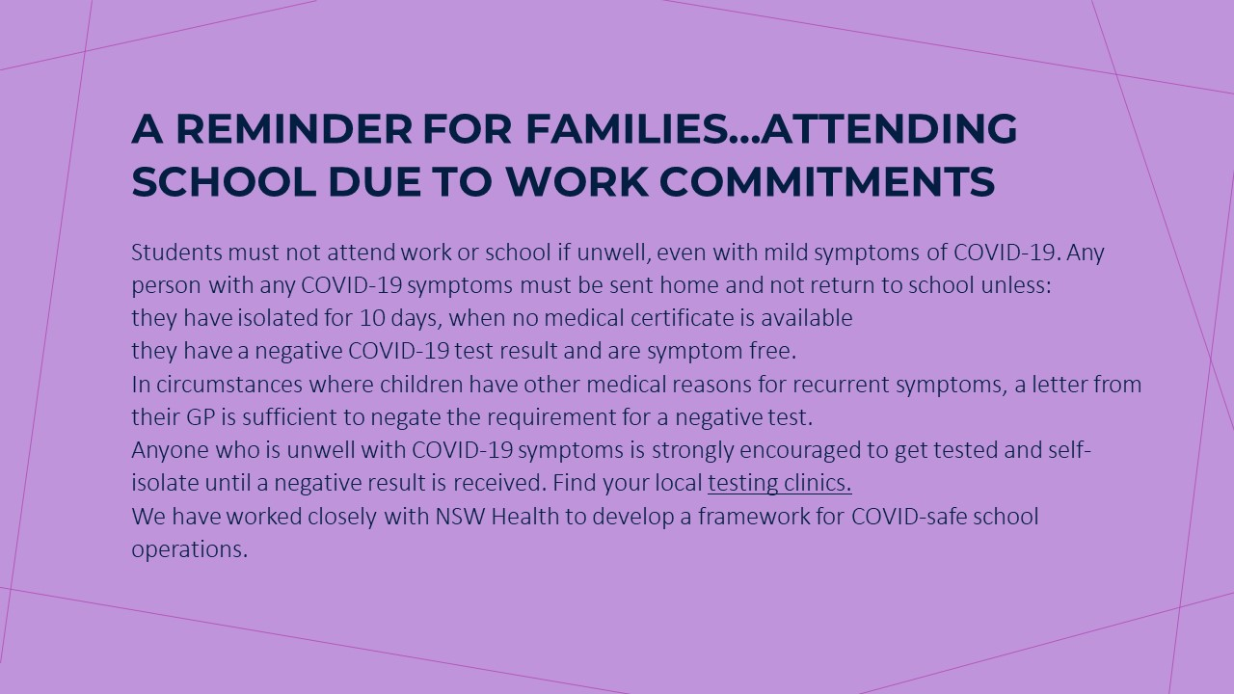

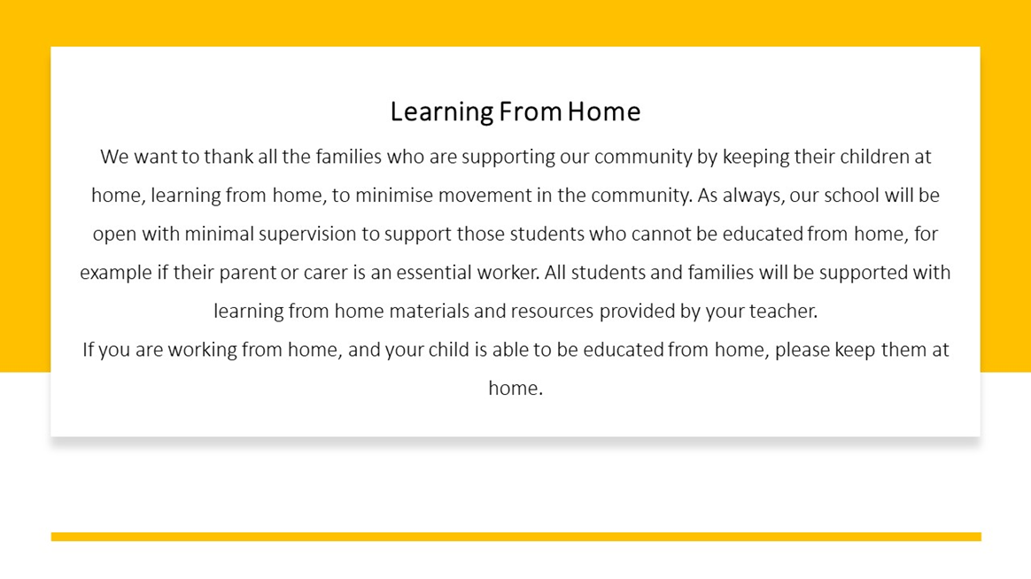

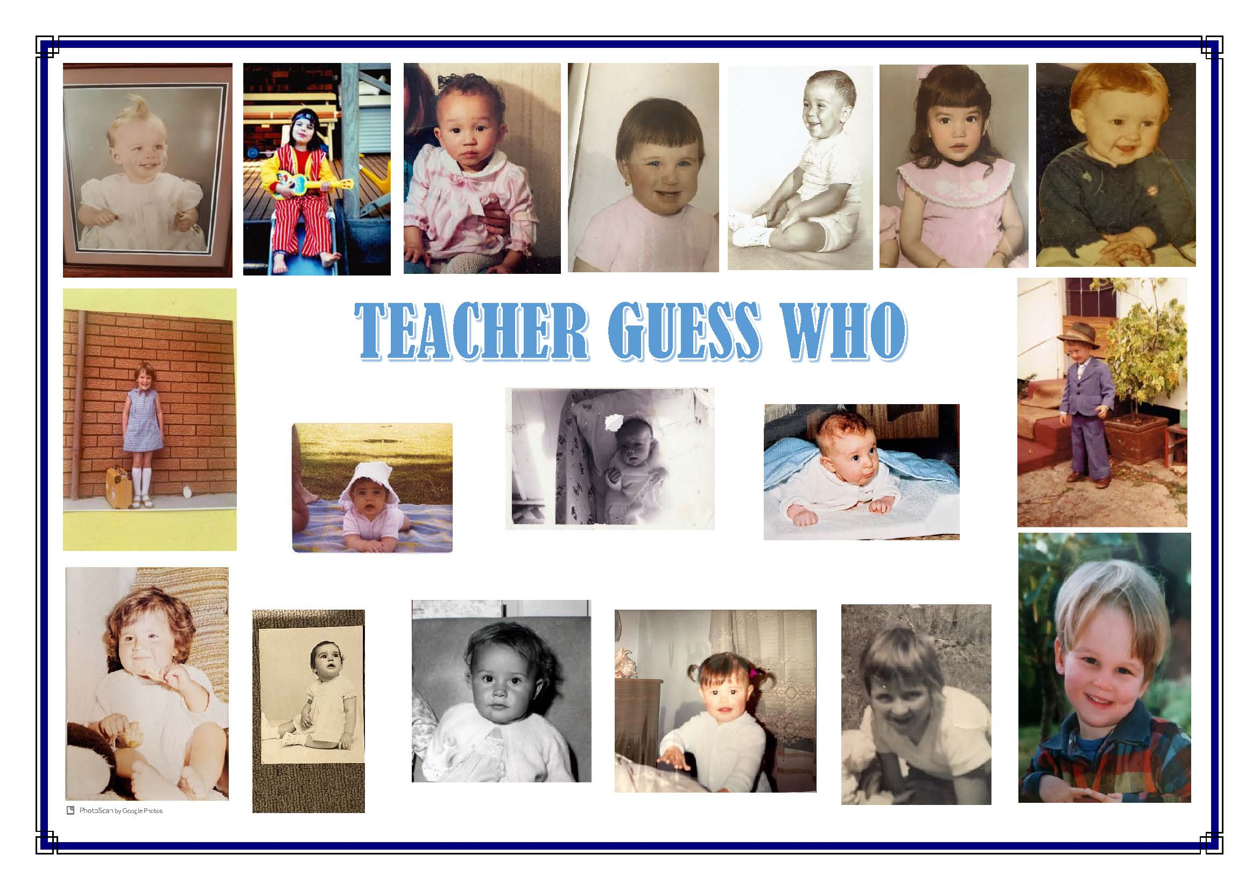
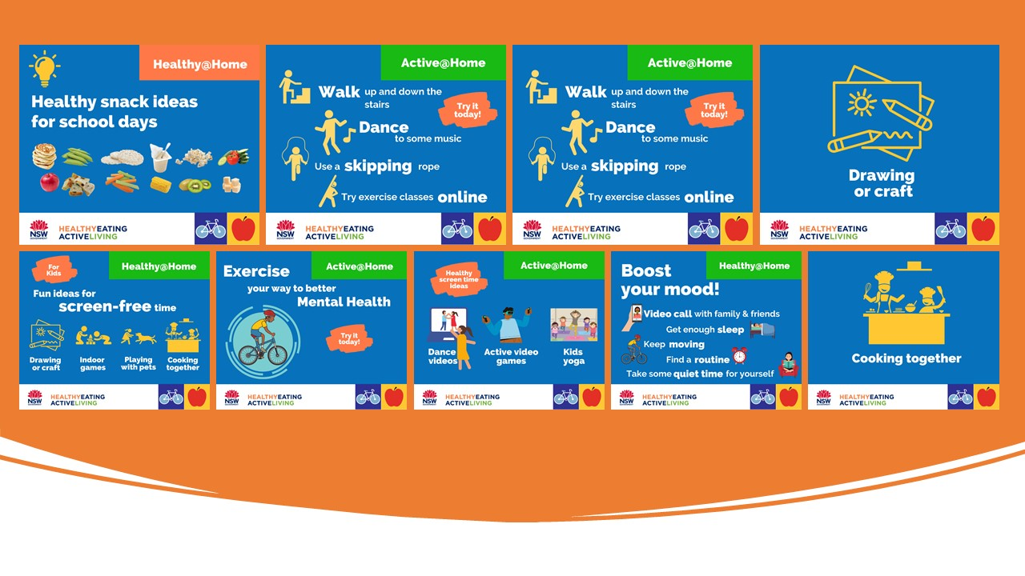
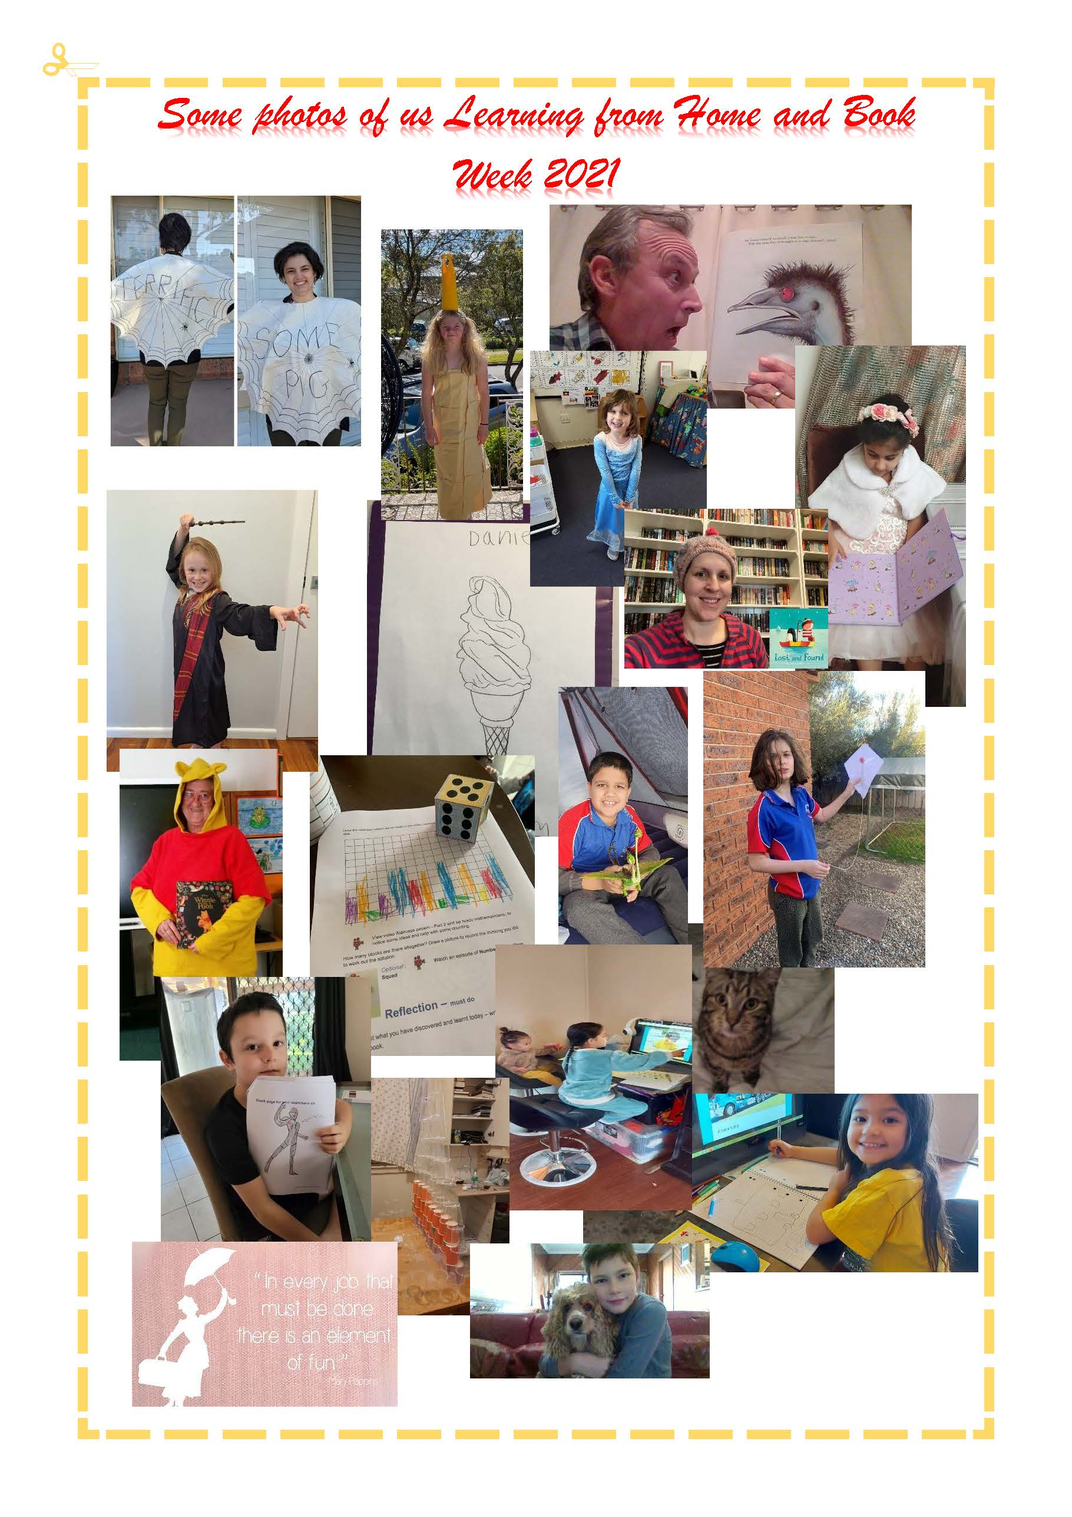
ENROLMENT DETAILS FOR 2022 SCHOOL YEAR

Dear Parents and Carers,
At this time of year we begin preparing classes and teaching staff for the coming year.
It would be of great assistance if we were advised if any student would not be returning to our school next year. Similarly, we would like to know if any students will be returning late to school due to overseas holidays.
Please indicate below if you WILL NOT be returning to Lalor Park Public School in 2022.
Please also indicate if your child will be returning to school in the new school year.
Thank you for your assistance in this matter.
Mrs Deanne Taylor

Principal

LALOR PARK PUBLIC SCHOOL 2022 SCHOOL YEAR
I wish to advise that my child/ren……...………………………………………………………………….. of class ………………………………………………………WILL NOT be returning to Lalor Park Public School due to …………………………………………………………………………………………………………….……………..
My child/ren …………………………………………………………………………………………………..………..
WILL BE returning to school on …………………………………………………………………………………..… (Date) due to …………………………………………………………………………………………………………..
………………………………………………… ……………………………………………………………….
Parent signature Date

